Figure 1: BP/1/356 Mounted monochrome full-length, portrait of Boole from The London School of Photography, 174 Regent Street, London
Credit: Used by permission of The Papers of George Boole, F.R.S., © UCC Library, University College Cork, Ireland

Figure 2: BP/1/220 Letter from George Boole to Sir William Hamilton (1852)
Credit: Used by permission of The Papers of George Boole, F.R.S., © UCC Library, University College Cork, Ireland

Figure 3: BP/1/352 Photograph of an illustration of Boole taken from The Illustrated London News 21 Jan. 1865
Credit: Used by permission of The Papers of George Boole, F.R.S., © UCC Library, University College Cork, Ireland

Figure 4: BP/1/361 Monochrome photograph of Mary Boole seated outdoors in a garden
Credit: Used by permission of The Papers of George Boole, F.R.S., © UCC Library, University College Cork, Ireland

Figure 5: Figure from Mary's book discussing about teaching formulae related to $(n+1)^2$
Credit: Photograph from Mary Everest Boole Collected Works, 1931.

Figure 6: An example of curve stitching
Credit: Moira Chas

Figure 7: Portrait photograph of Alicia Boole Stott
Credit: With the permission of the University of Bristol Library, Special Collections (DM1718/A.98, Howard Everest Hinton Archive).

Figure 8: Hinton cubes as they appeared in his book The fourth dimension, left. On the right, a cube with the name of its components, from A new area of thought

Credit: Left, from Hinton’s book, The fourth dimension, 1912. Rigth, from Hinton’s book, A new era of though, 1888. Public domain.

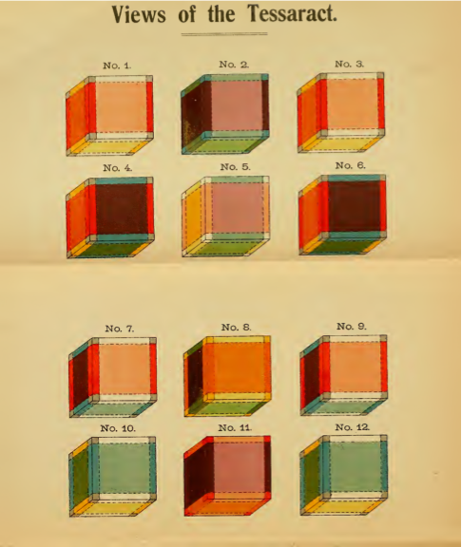

Figure 9: $3$-principal sections of the $16$ cell. Illustrations from \textit{A New Era of Thought} \cite{hinton1888new} (top left),
illustrations Alicia Boole Stott's paper \cite{stott1908sections} (right and bottom left).

Credit: Top left: From Hinton’s A new era of thought, 1888. Bottom left and right, from Alicia Boole article, 1900.

Figure 10: BP/1/363 Monochrome photograph taken outdoors of Professor Schoute, Alice Stott and her daughter Mary, Margaret Taylor and her son Geoffrey.
Credit: Used by permission of The Papers of George Boole, F.R.S., © UCC Library, University College Cork, Ireland

Figure 11: Representation of central sections of polytopes.
The two models were made by Alicia Boole and the three drawings by Schoute.
First and second correspond to the central $0$-principal section of the 600 cell.
Second and third to the central $3$-principal section of the $120$ cell.
The fifth, to the $3$-principal section of the $600$-cell. Compare this section to the central drawings in each row of Figure~\ref{fig:AB-sections}.
Polo-Blanco in her thesis, \cite[page 139]{polo-blanco_theory_2007}, placed the $600$-cell model and drawing together. The photograph of Alicia’s model of the section of the 600 cell was taken by her.
Credits: The photograph of Alicia’s model of the section of the 120 cell belongs to the University Museum at the University of Groningen. Used with permission.
The drawings are from Pieter Schote paper, 1894.

Figure 12: Alicia' drawings of $0$-principal sections of the $120$-cell (top), and $0$ and $3$ principal sections of the $600$-cell (middle and bottom, respectively).
Credit: The drawings are used with permission of the Special Collections Department of Groningen University Library (HS Add 394) The photographs of the drawings were taken by Dirk Fennema.

Figure 13: BP/1/362 Black and white copy of an earlier photograph of the Boole family showing Mary Boole, her five daughters and grandchildren, Julian and Geoffrey Taylor, Mary Leonard Stott and George Hinton, grouped in a studio portrait. Names annotated
Credit: Used by permission of The Papers of George Boole, F.R.S., © UCC Library, University College Cork, Ireland

Figure 14: Hinton Pitching Machine. Illustration from an article written by Hinton in Harpers Magazine in 1897.
Credit: Harper Magazine, 1897.

Figure 15: A page of the mysterious Voynich manuscript
Credit: This work is in the public domain in its country of origin and other countries and areas where the copyright term is the author's life plus 70 years or less.

Figure 16: Geoffrey Ingram Taylor (right) at age 69, in his laboratory with his assistant Walter Thompson. (AIP Emilio Segr\'{e} Visual Archives.)

