A stack of pamphlets entitled 'Asparagus and the Immortality of the Soul' (Which if you're interested can be read here - http://www.campanile.it/uk/asparagus.htm) are in the realm. Folded into each is a color-xeroxed pamphlet, liberally decorated with the art of Alex Grey (http://www.alexgrey.com/) and Gustav Dore (http://dore.artpassions.net/) and with Zapatista and Situationalist imagery.





"It is not our arms which make us radical; it is the new political practice which we propose ... : the construction of a political practice which does not seek the taking of power but the organization of society. ... We are so radical that we do not fit in the parameters of "modern political science". We are not bragging … we are pointing out the facts. Is there anything more radical than to propose to change the world? You know this because you share this dream with us, and because, though the truth be repeated, we dream it together."



From a drunken slumber we awake, for the alien life has called our name. In a great banquet hall are we, with soporific music and thick, honeyed wines. And, awaking, we see that we have been lulled by our jailers, and have become men of the dwelling.

Five Archons there are who jail our souls, who guard the aeons lest we escape. Cuhlash Carromb, motion without direction. Peela Sutulu, longevity without health. Rex Imperator, the cobweb-muted spy. Authority without mandate. Quias Quarrot, definition without understanding, mapping without discovery. Meiji Salas, Mammon reborn - he whose chains are gilt and choking. Awake from their unctuous feast.

"The bird fights its way out of the egg. The egg is he world. Who would be born must first destroy a world. The bird flies to God. That God's name is Abraxas."

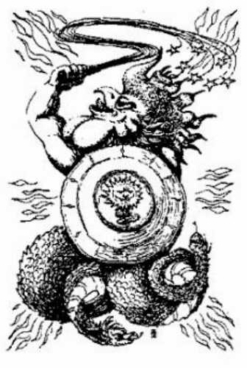

A divinity beyond definition is occluded from our senses. Riotous sounds deafen our ears, and yet we awake. We awake and call to our brothers who still sleep, but they cannot hear us. Only the alien life can call to its own, and breathe life into the sparks that smolder in ash.
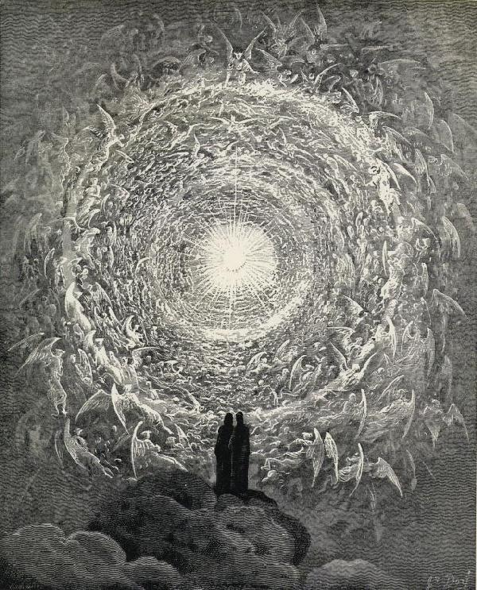
There are more people alive now than dead. The pleroma is so dissipated that there are those who walk among us who were born without souls. They are not to blame. Pity them, for the gates of the divine are closed to them. There are those, too, who awakened and seek only to pilfer the coats of the sleeping guests.

"I laugh at what you call dissolution;
And I know the amplitude of time."

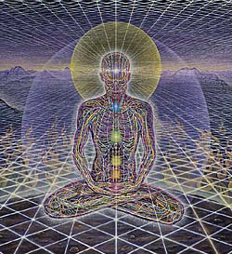

New Gods rise every day, and despair at the filth they find around them. Swine eat freely from golden platters. Goblets are overturned and delicacies mold and rot as the guests sleep still. How, then, to call the sleepers awake? How to rouse your brother from his slumber? Dream with him. Whisper in his dozing ear that he is a god forgotten, that he is a prince from a foreign land, that he was sent here to retrieve a pearl, and having found it must depart.

"Nobody, no matter how alienated, is without (or unaware of) an irreducible core of creativity, a camera obscura safe from intrusion from lies and constraints. If ever social organization extends its control to this stronghold of humanity, its domination will no longer be exercised over anything save robots, or corpses."
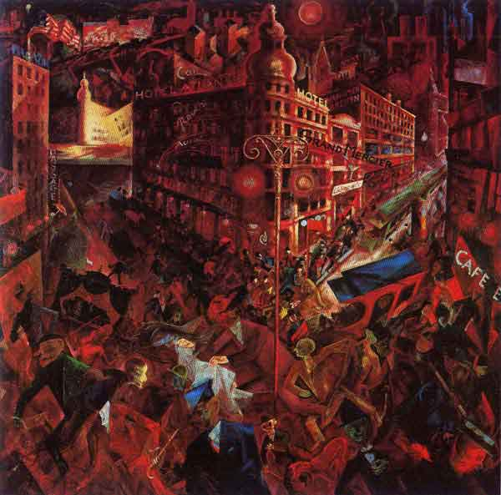
Their party is over. Ours is just beginning.
Collaborating with the Archons strengthens their hold on us. Time is a prison, space a cell within.
Dance, and let the Gods Within you awaken.


Baroness Judy, Collegium Invisibilis.

