SPRING 2015 PROGRAMS, WORKSHOPS & SEMINARS
Simons Center for Geometry and Physics | scgp.stonybrook.edu | Spring 2015

SCGP NEWS

The 2014-15 academic year was marked by new developments in the Simons Center for Geometry and Physics. For the first time in its seven-year history the Center decided to experiment with the lengths of its programs. The first one to implement the change was Interactions of Homotopy Theory and Algebraic Topology with Physics through Algebra and Geometry. Organized by John Morgan and Dennis Sullivan, it ran from October 1, 2014, to June 30, 2015. The organizers of the program spread its activities over the entire academic year, rather than concentrating its activity in one semester, with between four and six visitors in residence at any one time.

While activities were organized around several general themes, e.g., rigorous approaches to perturbative quantum field theories, formal quantization, and TQFTs and infinity structures, partial list of topics included BV algebras, operads, the Fukaya category, various compactifications of moduli spaces of stable curves and stable maps, as in string topology and contact homology and twisted K-theory. As part of the program, the Founding Director of the Simons Center Dr. John Morgan gave a series of lectures titled A further look at Verdier duality, examining Verdier duality for locally compact spaces of finite cohomological dimension, giving some explicit examples of the dualizing sheaf, showing that this duality is exact and preserves quasi-isomorphism and that a complex of sheaves is naturally identified with its double dual. This was preceded by another series of lectures titled A topologist looks at Sheaf Theory, given by Dr. Morgan as part of the same program in the Fall 2014.

Another fortuitously timed program was Mathematical Problems in General Relativity. The year 2015 marks the centennial of the birth of Einstein's Theory of General Relativity, and it is being celebrated with numerous conferences and meetings of physicists and mathematicians the world over. This Simons Center program ran from January 5 to February 6, 2015 and was organized by Michael Anderson, Sergiu Klainerman, Philippe LeFloch, and Jared Speck. The program and its namesake workshop were dedicated to a wide variety of themes covering many recent developments in mathematical relativity, such as aspects of the well-posedness problem for the Einstein equations, (related to the recent breakthrough on the solution to the bounded L^2 curvature conjecture by Klainerman-;Rodnianski-Szeftel); the nonlinear stability of black hole spacetimes; the formation of trapped surfaces, the global causal structure of spacetimes. A number of new results were announced at the workshop, including those by S.J. Oh (on linear stability of Cauchy horizons), M. Dafermos (on nonlinear properties of Cauchy horizons), P. LeFloch (on weak solutions to Einstein equations), and Mu-Tao Wang (on quasi-local angular momentum).

Knot Homologies, BPS States, and SUSY Gauge Theories, organized by Sergei Gukov, Mikhail Khovanov, and Piotr Sulkowski, ran from March 16 to June 12, 2015. The aim of the program was to understand the new relations between knot theory, supersymmetric field theories, and string theory and to use the language and tools that they provide to find a natural interpretation of powerful mathematical formulations of knot homologies. Among the program’s seminars a series titled Introduction to Floer homology was given by Simon Donaldson, laying the foundation of the theory. Edward Witten gave an insightful talk on analysis of PDEs in five dimensional gauge theory, whose solutions capture Khovanov homology and its variants.

The program was marked by developments of useful tools that help in computing homological invariants of knots and links, including the very definition of colored HOMFLY-PT homology by Oblomkov and Rozansky. (Cont.)

Groundbreaking results of Oblomkov-Rozansky’s work were first announced at the workshop and immediately caught a lot of attention. They gave a rigorous mathematical formulation of “colored HOMFLY-TP homologies of knots” that were predicted (and even computed in many cases!) from physics, but remained mysterious mathematically. This “gap” was one of the biggest challenges in the field for the past several years since many groups (in math and in physics) have been working on colored HOMFLY-PT homologies, trying to understand their structure, even without a proper mathematical foundation. And the work of Oblomkov-Rozansky has closed this gap.

Large N Limit Problems in Kahler Geometry, organized by Robert Berman, Semyon Klevtsov, Paul Wiegmann, and Steve Zelditch, ran from April 20 to June 19, 2015. This program centered on the use of holomorphic sections of high powers of positive Hermitian holomorphic line bundles over a Kahler manifold to construct projective embeddings, Bergman Kahler metrics, and Gaussian random fields, the main tool being the Bergman kernel and its large N asymptotics, on and off the diagonal. Its asymptotics has many applications in geometry, probability theory and mathematical physics. The main objects arose in the Yau-Tian-Donaldson program of relating GIT stability and Kahler-Einstein metrics, but the focus of the program was on holomorphic stochastic geometry and mathematical physics.

Contents
_____________________

3 Math and Science Intertwined. Maxim Kontsevich
4 Conversation with Edward Witten
5 Della Pietra Lecture Series
6 Organizing Equations on the Iconic Wall by Tony Philips
8 The Simons Center Gallery and Art Program
9 Unveiling of the Iconic Wall
10 The SCGP Café Presents
11 Take a Peak into Maestro’s Kitchen
12 Upcoming Events

Newsletter production:
Maria Shtilmark
Elyce Winters
Design by: Fiona Cashell

For issues of the SCGP newsletter, please visit
http://scgp.stonybrook.edu/news/newsletters

For questions and comments, please, contact 631-632-2800
Simons Center for Geometry and Physics
State University of New York
Stony Brook, NY 11794-3636
U.S.A.

List of cut-ins that will spread all over the newsletter:
Visit our website to apply for or attend one of the upcoming programs or workshops
http://scgp.stonybrook.edu/apply

Join our mailing list at http://scgp.stonybrook.edu/mailing-list

Like SCGP Café on Facebook or visit their website for daily changing menu http://scgp.stonybrook.edu/cafe

For more about the Art Program and the Simons Center Gallery updates, please visit http://scgp.stonybrook.edu/art
The SCGP welcomes proposals for scientific programs and workshops 2016, 2017, 2018. For possible sabbatical stays, please contact Elyce Winters at elyce.winters@scgp.stonybrook.edu
Math and Physics Intertwined.
Conversation with Maxim Kontsevich, AXA-IHÉS Chair for Mathematics, IHÉS.
Among plethora of Kontsevich’s awards are Henri Poincaré Prize, 1997, Prize of the International Congress of Mathematical Physics, Brisbane 1997, Fields Medal, IMU, ICM Berlin 1998, Crafoord Prize 2008, Shaw Prize in Mathematical Sciences 2012, Fundamental Physics Prize 2012 Breakthrough Prize in Mathematics 2014, along with SCGP’s own Simon Donaldson.

Your lectures at the Simons Center for Geometry and Physics were dedicated to exponential integrals. How does this subject connect geometry and physics? It connects the two directly, because in physics you write Feynman integrals of the exponent of the action integrate over fields, and it formally looks like integrated exponent of some polynomial, and one can develop similar story in finite dimensional algebraic geometry and make some conclusions about some geometry, topology, and these were the topics I covered in my lectures. The subject is developing, I have had some new results, and I think I will talk about them during my next visit in August.

We all are looking forward to them! It is often said about you that your work has changed the way physicists think about string theory, and the way mathematicians think about mathematics. What do you yourself consider your main contribution to bridging the gap between physics and math? It is a little bit hard for me to say, because I have been involved in dialogue between the two for twenty years at least, may be twenty five. One of the things I have done is introduction of homological mirror symmetry. It was done kind of right on time, before physicists did it, they call it D-branes, and it was very useful for both communities. Physicists learned how to understand such objects as triangulated categories and homological algebra, and as for us, mathematicians, in order to understand the structure of the subject we have to look at what physicists write in their papers and try to get ideas from them.

One of your teachers was Israel Gelfand, one of the most outstanding mathematicians of the 20th century, also involved in physics. Was your connection to physics partly his influence? Yes, I was part of his Moscow seminar at a great time, when conformal field theory was born, truly before our own eyes, by Belavin, Polyakov, and Zamolodchikov. I remember how physicists came to Gelfand’s seminar and gave talks on it. In fact, they drew their inspiration from works by Feigin and Fuchs, from the Gelfand’s school. So, this was a wonderful interaction between mathematics and physics, and back, and I have been involved with this it since my mathematical childhood. At some point Gelfand thought that I should pass Landau’s “Theoretical Minimum” physics exam, yet this plan for me didn’t materialize. As for his influence in general it’s a bit hard to say, as I was very independent from the very beginning and tried to keep some distance between us, so the influence was more indirect, coming from his seminar.

In your Shaw Prize interview you mentioned your interest in cello and Baroque and Renaissance music. Could you tell us a little more about that? Yes, this is some of my personal history. My best friend’s mother is a musician and a cello teacher, and when I was in high school visited them often, and became involved in music. But I really had time for it after only I finished university, when for four or five years I played with a group of friends in Moscow. My friend, a professional musicologist, was the main motor of this group. He was exploring various old and unknown pieces of music. At that time we ordered some microfilms from a London library to Moscow through interlibrary exchange, printed them, and discovered some truly old pieces of music, not of great quality maybe, but we were the first to play it in a few hundred years.

Recently science and scientists have become a focus of filmmakers’ attention: Imitation Game, Interstellar, Theory of Everything, etc. Why this sudden interest? I really can’t fully answer, except for they must be looking for new topics. I am not a big movie watcher. I used to watch art films a lot while I was in still high school, but some time ago, I must say, I lost interest in the field. It is a completely perpendicular world.
Maxim Konstevich will give talks at the Simons Center on August 20 and 25, 2015.

Conversation with Edward Witten, Professor of Mathematical Physics, IAS.

Professor Edward Witten, with the Institute for Advanced Study, gave a series of talks at the Supermoduli workshop, a talk at the Future Prospects for Fundamental Physics workshop, and a talk at the Physics and Mathematics of Knot Homologies workshop as well, thus contributing to a solid recognition of Spring 2015 as uniquely productive period at the SCGP.

One of the incredible things about the Supermoduli workshop was its pace - you, among 2 other organizers, were giving daily talks for the duration of the workshop. And still, at the end of each lecture the audience was still hungry for more!

I hope so. I can tell you as a speaker, one always explains less on any given day than one was hoping to.

Do you feel that the 5 talks, entitled "Holomorphic Methods in Low Genus", covered your bases on the subject?

They had to, though I had not originally been expecting to spend 2 lectures on foundational matters, as much as I did. But the lectures were kind of fun.

The Supermoduli was the first workshop in the SCGP in this field. How did this subject emerge, and what is its importance for string theory (and pure mathematics)?

Super Riemann surfaces are a generalization of classical Riemann surfaces. Classical Riemann surfaces are a topic in by now very classical mathematics, started in the nineteenth century. There is by now a huge and very powerful theory. It has a surprising generalization in super Riemann surfaces, where we consider odd or quantum variables in the geometrical structure. And the super Riemann surface theory is the most natural framework to understand superstring theory in a situation in which we can understand it well – namely when the quantum affects are small.

It is a rather old field, which was developed to some extent in the 1980’s and was neglected after that. Some of us have gotten interested again, and are trying to understand it better. So the workshop we have just had was the first workshop on super Riemann surfaces in the 21 century!

At the Future Prospects for Fundamental Particle Physics and Cosmology workshop your talk was entitled "Some Remarks on Time Dependence in String Theory". Why is this an important topic for the future of string theory and physics in general?

String theorists have discovered lots of crazy non-classical things about the behavior of space, when string theory departs from classical ideas in geometry and surprising things happen. But we don’t have a good understanding of the behavior of time. And probably there are surprises there, which may be important for understanding black holes and the Big Bang, although we do not know anything for sure.

In an interview almost 30 years ago, you quoted the Italian physicist Daniele Amati, who reportedly said that “string theory is part of 21st-century physics that fell by chance into the 20th century”. How do you view this quote now? Does it feel like string theory fell from the 22nd century?

This remark was actually quoted to me by a third person, and I have been mentioning it in interviews and talks since the mid-1980’s. Assuming it was Amati who said that first, what he meant by it must have been that the physicists who discovered string theory stumbled into it without having any idea what they were finding, without really looking for it. By contrast, Einstein had a conception for what he wanted when he was developing the theory of gravity, and he discovered general relativity with the ideas first, and then finding the technical framework.

But string theory was discovered with no inkling of the conception in mind. In a sense, it was discovered by chance. In part, the reason for this chance is that string theory has many different manifestations; there are probably a number of ways how one could discover it, and each of them would look rather unlikely. But in any event, string theory was discovered around 1970 without knowing the conception behind it, and 45 years later we have made a lot of very interesting and surprising discoveries, but we still don’t know the concepts behind it, really.

As for the question whether string theory fell from the 22nd century, I would say there is still some hope for the 21st.

You have been involved with the SCGP since its creation. How do you see the role of the Center in the landscape of similar institutes worldwide?

The Simons Center is a very exciting center for mathematics and physics and their interactions. That is why I have been attending three workshops here this month. It has been an exciting month, but I can’t maintain that pace indefinitely. For one thing, I’d get too many complaints at home.

Some of the Institute’s photos with supermoduli talk

Caption:
James H. Simons, the Simons Center trustees SUNY Professor of Mathematics Dennis Sullivan, Professor of School of Natural Sciences Edward Witten, Donner Professor of Science Cumrun Vafa, and visiting professor of Physics Samson Shatashvili before the SCGP inaugural conference in 2010.
http://scgp.stonybrook.edu/multimedia/photo-gallery/nggallery/events-2/event-opening-gala

The past spring was marked by 2 exciting editions of the Della Pietra Lecture Series, made possible by a generous donation from the Della Pietra family. The series aims to bring world-renowned scientists to the Simons Center for Geometry and Physics to enhance the Center’s intellectual activity and bring greater awareness of recent and impactful discoveries in physics and mathematics to the Long Island community.

Each edition of the series includes a technical talk, a high school lecture, and a lecture for the general public. The first one was given by Dr. Etyenne Ghys on January 20, 2015 in the Simons Center Auditorim. Dr. Ghys’s public lecture, which was preceded by a wine-and-cheese reception at the Center’s lobby, was titled The story of flat surfaces. Dr. Ghys, the Director of Research at L’École Normale Supérieur, is a mathematician, and, as introduced by Dr. John Morgan, he is well known for his work in “geometry, topology, dynamics and their union”. His lecture revolved around the notion that, despite the fact that most surfaces are not flat, we nevertheless, try to cover them with flat objects. Cartographers picture our round Earth in planar maps; soccer balls used to be made from flat pieces of leather; tailors cover our very non-flat bodies with clothes made out of fabric. Dr. Ghys’s story started with Euler’s beautiful developable surfaces (1770), continued to Thurston’s pleated surfaces (1980), and of course did not forget the official soccer ball of the World Cup in Brazil (2014). Following Chebyshev (1878), Ghys showed how to clothe a round ball with no wrinkles (2011), and mentioned the incredible flat surfaces by Borrelli et al (2012), following the theorems of Lebesgue (1898) and Nash (1954). Still, he impressed the audience with how many questions in the field remain unanswered.

More excitement was to follow, as on March 31 Dr. David Gross, Chancellor's Chair professor of theoretical physics, KITP, Nobel Prize in Physics 2004 for discovery of asymptotic freedom, a phenomenon that changed high energy physics, gave a talk titled The frontiers of fundamental physics. Dr. Gross dedicated his Della Pietra talk to experiment and theory. He spoke in depth about experimental supremacy of LHC and how it has altered our understanding of matter, and his expectations for more exciting news from CERN. According to Dr. Gross, within the next few years these discoveries will change the balance between theory and experiment, and we will have a new perception of whether our ignorance is finite...
poster and headshots
Next Edition of the Della Pietra Lecture Series will be held October 1-2, 2015 and feature Dr. Bonnie Bassler, Squibb Professor in Molecular Biology, Chair of the Department of Molecular Biology, Princeton University. For more information on Dr. Bassler’s research please, visit http://molbio.princeton.edu/faculty/molbio-faculty/31-bassler
Organizing Equations on the Iconic Wall
By Tony Philips
Image 1 Tony’s Headshot

After Jim Simons accepted Nina Douglas’ proposal for a limestone wall in the SCGP lobby with mathematical and physical equations and diagrams, inspired by the exterior of the Bibliotheca Alexandrina, the new Library of Alexandria, (this was back in Spring, 2010) a committee was set up to solicit—from the Math, Physics and SCGP faculty—suggestions of which equations and diagrams, ranging over the entire history of the sciences, should be included. Nina and I were entrusted with the design.

The committee solicited, and the suggestions came pouring in. At the final count, a couple of months later, there were almost ninety items, each of which some professor thought worthy of being carved in stone for the ages to come. Twenty of these involved diagrams: geometric figures, experimental apparatus, or images of physical and numerical phenomena.

The wall is quite large (roughly 20 by 24 feet) so there certainly was room for many equations and many diagrams. But how should they be arranged? The Bibliotheca displayed inscriptions and tokens from all the world’s cultures, written as if at random, some large, some small, all clearly used just for symbolic and decorative effect. Such a purely paratactic arrangement did not seem suitable for a context where the meaning of each element was essentially important.
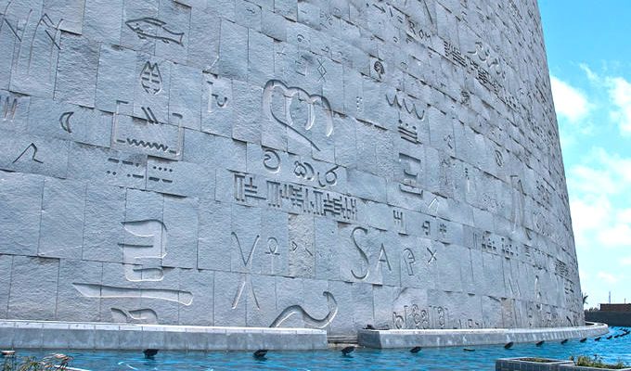
Image 2 https://commons.wikimedia.org/wiki/File:Words_on_a_Wall.jpg
Caption: Detail of exterior wall, Bibliotheca Alexandrina. Image from Wikimedia Commons.

On the other hand, the branches of physics and mathematics had evolved over the years to where, even though one could find links between any two of them, no simple, two-dimensional overall scheme could encompass them all.

The first job that Nina and I faced was to get the number of items reduced to what could fit on the wall in a legible font without crowding. After several consultations with the faculty, and a certain amount of necessary compromise, the committee selected for inclusion thirty two equations, including sixteen with diagrams. (Cont.)

Our next task was the layout. To handle the diagrams we fell back on a scheme from the Renaissance, using thirteen medallions around the periphery of the wall to enclose each diagram and its equations. Images 1 and 2

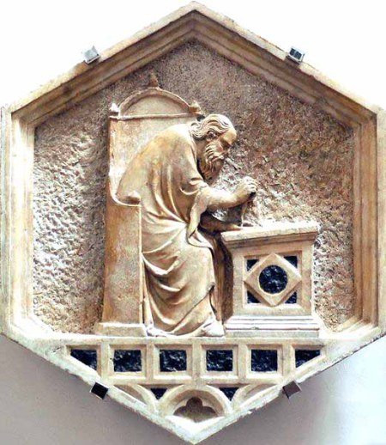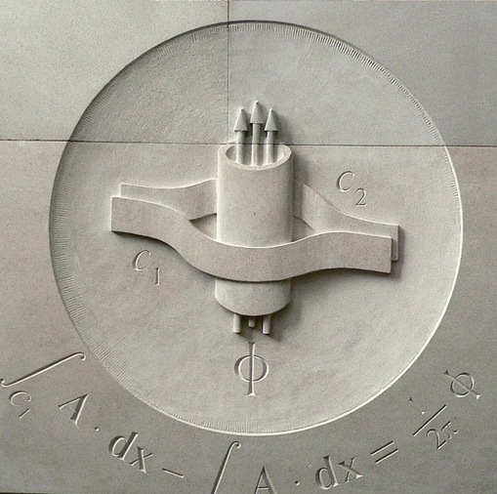
Caption: Left, Euclid, by Nino Pisano (early 14th century, Museo dell’Opera del Duomo, Florence).
Right, Aharonov-Bohm Experiment, by Christian White. These two works are approximately the same size.

Two of the diagrams did not fit comfortably in a medallion: one was the picture of a planet in elliptical orbit about the sun, illustrating Kepler’s laws. Our solution was to narrow the ellipse and expand it to take up almost the whole diagonal of the wall, angled opposite to the slant of the staircase (which functioned as an additional constraint on the entire project). This effectively portioned the surface into two parts. Of the remaining fourteen equations, nine fit inside the ellipse (including Kepler’s laws, Newton’s laws and Einstein’s gravitational equation).
The other diagram needing more space was the string-theoretic enhancement of a Feynman diagram. Our solution here was to interpret the particle paths as energetic rays from the Sun (the focus of Kepler’s ellipse) and to use those paths to sketch a large triangle counterbalancing the ellipse.
That left seven equations to live outside the ellipse, including Maxwell’s Equations and Einstein’s E = m c², which occupy their rightful place at the top of the design.

Dr. Anthony Phillips is Professor of Mathematics at Stony Brook University. His main field of research is algebraic topology. To listen to Dr. Philips’ talk on selecting the equations, along with talks by Nina Douglas and Christian White on conceptual and artistic aspects of the project, please go to http://media.scgp.stonybrook.edu/video/video.php?f=20150508_4_HD_qtp.mp4. For documentation of the history of the project, please go to http://www.math.stonybrook.edu/~tony/scgp/wall-story/wall-story.html

The Simons Center Gallery and Art Program
[KE]3: dc-motors, cotton balls, and cardboard boxes

[KE]3, a solo exhibition of Zimoun, an internationally acclaimed Swiss artist of kinetic sound sculpture, architecture, and installation art, was on view at the Simons Center Gallery from February 5 to April 9, 2015. Curated by Lorraine Walsh, Artistic Director and Curator at the gallery, the exhibition was an integral part of three concurrent solo exhibitions in New York—at bitforms gallery and Knockdown Center. The approximately 2,500 visitors to the exhibition included Stony Brook University students and faculty, visiting scholars at the Simons Center for Geometry and Physics, local community members from Long Island and New York City. Particularly, more than 300 visitors, including staff from Consulate General of Switzerland, attended the opening ceremony, accompanied by Zimoun’s lecture titled “Primitive Complexity.”
KE, part of the exhibition title, refers to the physics symbol for kinetic energy, describing the energy an object possesses due to its motion. Zimoun creates kinetic sculptures and sound installations finding uncommon aesthetic potential in commonplace objects. Combining raw industrial materials, such as cardboard boxes, cotton balls and filler wire, with finely tuned mechanical elements, like dc-motors, wires and microphones, Zimoun’s work results is an unexpected beauty in aesthetically timed minimal artistic environments, that take on a life of their own. Exploring mechanical rhythm and flow in prepared systems, his work suggests a balance between orderly patterns of Modernism with underlying chaotic forces. Zimoun’s installation and sounds cantillate an acoustic hum of natural phenomena in minimalist constructions that effortlessly reverberate in space.
A series of educational and public programs in relation to Zimoun’s exhibition fulfilled the Simons Center Gallery’s primary goal to connect wider communities, on and off campus, interested in both art and science. The Simons Center Annual Bus Trip for Art students commenced with a visit to Zimoun’s exhibition at the Simons Gallery, to continue with the artist’s exhibits at the alternative art space Knockdown Center in Maspeth, Queens and concluded the visit at Bitforms Gallery, NYC. Art students in the MFA program joined the students from Lorraine Walsh’s Museum Studies class.
Zimoun’s closing reception on April 9, 2015 coincided with the Annual Art Crawl during the SSK Arts Festival at the Simons Center Gallery. The Art Crawl is a collaborative event with all the galleries on campus. Students pursuing their MFA's volunteer as docents, leading the community through the galleries, the Simons Center Gallery part of the tour. The Crawl commenced at the Paul W. Zuccaire Gallery, continued to the SAC Art Gallery, ending at the Simons Gallery with a reception and the opportunity for visitors to make an art box reflecting the artwork created by Zimoun.
New collaboration has been established between the Simons Center Gallery and the SUNY College of Arts, Culture and Humanities. Freshman students receive 1 credit hour for touring the gallery. As part of the first year experience, students select from a number of activities on campus to attend. Visiting Associate Professor Lorraine Walsh gives a talk in the gallery for the art students.

This coming summer and fall the art program at the Simons Center Center will continue to host exciting events that explore ways in which art and science intertwine. For more information on the Simons Center Art Program, please visit scgp.stonybrook.edu/art.

Move Mohr’s update here?
Photos

The Wall
Unveiling of The Iconic Wall took place on May 8, 2015 at the Simons Center for Geometry and Physics. Festive ceremony began by solemn dedication in the Simons Center Lobby, led by the Simons Center’s founding Director Dr. John Morgan, whose speech was followed by President Samuel L. Stanley, and James H. Simons. The gathering continued in the Simons Center Auditorim with entertaining and insightful talks by Stony Brook University mathematician Dr. Anthony Phillips, Dr. Nina Douglas and the artist Christian White about the history and implementation of the unique Iconic Wall project.
In case
THE ICONIC WALL: MILESTONES in MATH and PHYSICS
May 8, 2015 – August 27, 2015, co-curated by Lorraine Walsh and Christian White
The Simons Center Gallery is hosting an exhibition titled the Iconic Wall: Milestones in Math and Physics. This exhibition is in conjunction with the Iconic Wall, a site-specific artwork displaying significant equations and diagrams in mathematics and physics. Originally carved in stone by Christian White, the work is based on a design by Anthony Phillips and Nina Douglas. The Iconic Wall is permanently installed in the Simons Center lobby.
Celebrating this unique work, Milestones in Math and Physics features a historical timeline detailing the equations and physical diagrams on the Iconic Wall. Also showcased are videos about the making of the wall. Notably, some of the original Indiana limestone, carved by the artist Christian White, is on view in the gallery.
The Simons Center Gallery is now a publisher registered with The Library of Congress (image of Iconic Wall booklet cover?)

Photos of the Unveiling (Coming today?)

SCGP CAFÉ Features
Organic Egg Sandwich
The breakfast egg sandwich—fried or scrambled eggs, bacon, and American cheese served on a bun - is a popular morning offering found in delis, take-outs, and convenience stores all over Long Island and New York City. Its humble origins, a quick on-the-go breakfast for a construction or an office worker, or anyone in a hurry, belie its delicious and satisfying combination of eggs and bacon. It is the true American breakfast. The sandwich was the perfect item to add to the SCGP Café’s morning menu due of its appeal to the students in need of nourishment before their 8am classes. Once the word was out, the Café’s breakfast egg sandwich has become our best-selling morning item.
Ingredients
3 Organic Eggs
2 Slices American Cheese
2 Slices Applewood Smoked Bacon
1 Brioche Roll (We use Eli Zabars New York City Brioche Roll, available at elizabar.com)
1 Teaspoon Unsalted Butter
Salt and Pepper To Taste

Method
-Preheat oven to 325 degrees.
-On a cookie sheet, lay bacon flat on parchment paper, and roast until crispy.
-Meanwhile, in a heavy bottomed sauté pan, heat butter until foamy.
-Prepare eggs to your liking, be sure to season well with salt and pepper.
-For scrambled eggs, using a fork, whisk vigorously in separate bowl, with a tablespoon of cold water, this will give you fluffy scrambled eggs.
-For fried eggs with a runny yolk, it is best to use the freshest eggs possible.
-When eggs are cooked, lay slices of cheese on top.
-Slice and toast brioche roll.
-Remove bacon from oven, and assemble sandwich. Enjoy hot, feel free to garnish with hot sauce or ketchup.

Chef Paolo’s interview for the weekly lifestyle publication Dan’s Papers in The Hamptons, celebrating Long Island unique summer food culture, full of ideas and advice.
http://www.danspapers.com/2015/06/scgp-cafes-chef-paolo-fontana-raises-a-glass-to-dans-harvest-east-end/

Take a Peak into Maestro’s Kitchen: SCGP Café’s Culinary Master Series

Consider yourself a foodie, enjoy cooking with seasonal ingredients, or just want to add high-end recipes to your menu? Chef Paolo Fontana and SCGP Café, winners of a 2015 Local Hero Awards from Edible Long Island http://www.ediblelongisland.com/2015/02/23/local-hero-award-goes-2/, have launched a project of culinary demonstrations titled Culinary Master Series. The idea stemmed from an introductory class held by the Café that proved so popular that it expanded into a series celebrating seasonal variety. 6 topical demonstrations were held during the past year: An Immigrant’s Thanksgiving; A Sicilian Christmas; Culinary Aphrodisiacs; Coming in from the Cold; Is it Spring Yet?; What Else? Cinco de Mayo.
Each event, attended by 20 to 30 participants—including students and friends of the café—kicked off with wine, before attendees turned their attention to chef Paolo’s artful cooking demonstration. Having shared some tricks of the trade, maestro saved time for extensive Q&A’s that always followed. Questions ranged from “Where can I obtain the ingredients” to trickier ones such as “I’ve tried making this and it failed me, why?” ones. Enlightened guests not only observe the preparation of delicious 3-course meals. To their enjoyment, the dishes are prepared and served to them by Café staff to complete the feast.
The following dates are being held to host this year’s culinary master series: September 8^{th;} October 13^{th;} November 10^{th;} December 8th. Stay tuned for the syllabus of themes for this year, with more exciting culinary ideas to follow. Impress your guests, rightfully being toasted to “Hail to the Chef!”
⁽February 9th March 8th April 12th May 3^{rd next year?)}

Photos of the Series

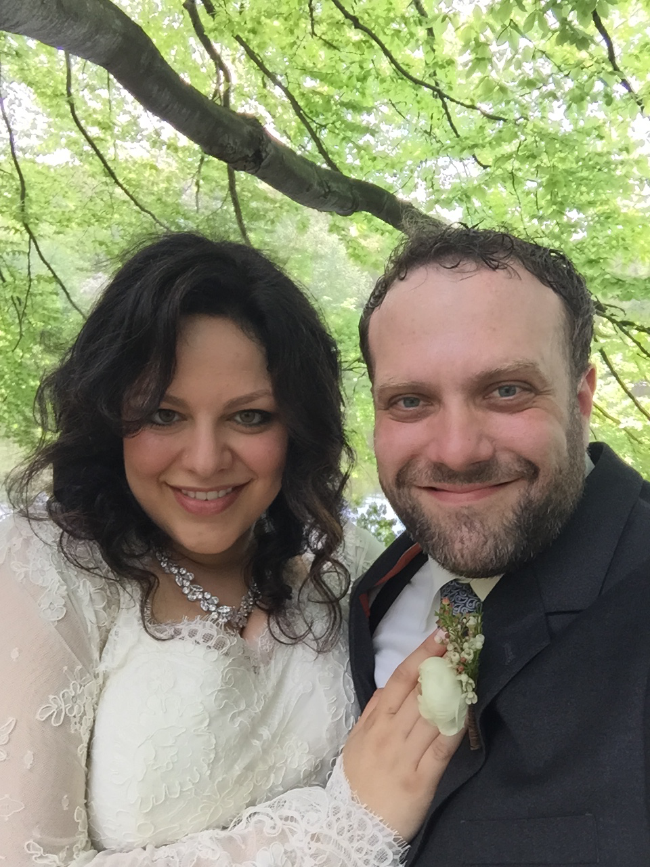 Janell’s!
SCGP Staff news -
Paolo Fontana and Lauren Moyer, now Fontana, married May 10, 2015. She owns a salon in St. James, and a baby Paolo Jr. is due in August.
Janell Rodgers and Nicholas Cianflone married on May 16, 2015
Postdocs Carlo Meneghelli and Mohammad Farajzadeh Tehrani have recently had babies – congratulations!

Coming Summer and Fall 2015
Workshops
Simons Summer Workshop 2015
July 20 – August 14, 2015
Gauge Field Topology: From Lattice Simulations and Solvable Models to Experiment
August 17 – 21, 2015
Collapsing Calabi – Yau Manifolds
August 31 – September 4, 2015
Random Matrices, Random Growth Processes and Statistical Physics
September 7 – 11, 2015
Graduate Workshop on Topological Quantum Field Theory
September 14 – 18, 2015
Toric Kahler Geometry
October 5 – 9, 2015
Symplectic and Algebraic Geometry in the Statistical Physics of Polymers
October 12 – 16, 2015
Random Matrix Theory, Integrable Systems, and Topology in Physics
November 2 – 6, 2015
Riemannian Convergence Theory
November 9 – 13, 2015

Programs
Moduli Spaces and Singularities in Algebraic and Riemannian Geometry
August 17 – November 20, 2015
Foundations and Applications of Random Matrix Theory in Mathematics and Physics
August 24 – December 18, 2015
Arts and Events
Iconic Wall – Closing Reception
August 27, 2015
Manfred Mohr – on view Sept. 10 – Nov. 12, 2015
Opening Reception and Artist’s Talk – September 10, 2015
Closing Reception – November 12, 2015
The exhibition of work by Manfred Mohr, an internationally acclaimed pioneer of digital art, will feature Mohr’s early digital drawings produced at Brookhaven National Laboratory by Dr. Peter Kemmey in 1969.

Concerts:
Tuesday, July 21, 2015 – (String Quartet?) Frank Bellucci, John Marshall, Steve Salerno, and Keenan Zach
Wine and Cheese Reception 5:30 pm. Concert 6:00 pm
Tuesday, July 28, 2015 – Organic Quartet: Ray Anderson, Tommy Campbell, Steve Salerno, and Gary Versace
Wine and Cheese Reception 5:30 pm. Concert 6:00 pm
Tuesday, August 4, 2015 – Leon Livshin
Wine and Cheese Reception 5:30 pm. Concert 6:00 pm
Tuesday, August 11, 2015 – Philip Carter, Dora Dimitrova, Natalie Kress, and Alison Rowe

Wine and Cheese Reception 5:30 pm. Concert 6:00 pm

